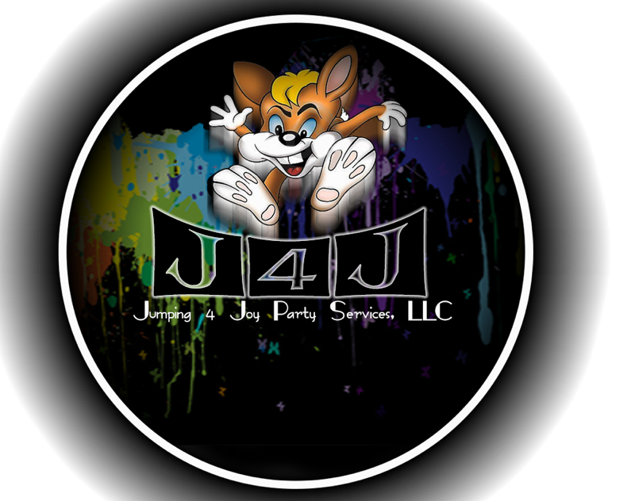

**Jumping 4 Joy Party Services, LLC**

**rental agreement**

|  |  |  |  |  |
| --- | --- | --- | --- | --- |
| **Renter’s Full Name:** | | | | **Rental Date**: ______/ ______ / **2023** |
| **Actual Event Start Time:** am / pm | | | **Preferred Setup Time**: am / pm | |
| **Phone Number**: (________) _________-___________ | | | **Event Ending Time**: am / pm | |
| **Onsite Staff Needed**: YES or NO  **Contract Number**: 1023____ (internal use) | **Deposit**: $ **Total Amount**: $  **Deposit Date**: **Balance Due**: $ | | | |
| **Mailing Address** (*promotional offers*):  **Event Address**: | **Event Typ**e (please circle one or specify):  Baby Shower Birthday Church Cookout Corporate  Family Reunion Graduation Wedding/Reception  Other: _____________________________________ | | | |
| **Unit/Equipment Requested:**   * Sports Bounce House * Hot Air Balloon Bounce House * Princess Castle Bounce House * Combo (6-in-1) Bounce House w/ Slide * Combo Sports Bounce House w/ Slide * Tropical Water Slide (18’) * Double Lane Slip-N-Slide w/ Pool (36’) * Obstacle Course (35’) | | * Clear PVC Bumper Balls (2 red & 2 blue) * Cotton Candy Machine w/ Cart * Popcorn Machine * Snow-Cone Machine * Hotdog Roller Machine * Pop-Up Tents (Carolina blue – up to 2) * White Folding Chairs | | |
| **Comments:** | | | | |

This Rental Agreement is made and entered into this ____ day of ______________ 2023 by and between the undersigned Lessee and Jumping 4 Joy Party Services, LLC. Lessee and Jumping 4 Joy Bouncers have mutually agreed that this Rental Agreement shall be subject to the information contained in this contract.

**PARTIES**: The Lessee hereby engages Jumping 4 Joy Party Services, LLC who agrees to furnish the item(s) described below upon the terms and conditions set forth herein.

**PAYMENT**: All reservations require a $25 minimum deposit and a signed contract. ***Full payment is due upon arrival at the event prior to setup***. Accepted forms of payment include cash, checks, money orders, and PayPal (***please add a 5% convenience fee***). Checks and money orders should be made out to Brian & Ashlynne Moulden. PayPal payments can be sent to [jumping4joybouncers@gmail.com](mailto:jumping4joybouncers@gmail.com).

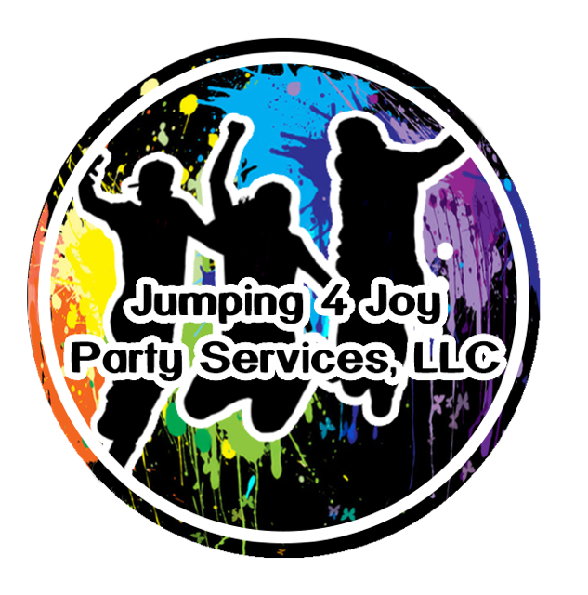

**TIMING AND FEES**: The reserved rentals shall be delivered no later than 30 minutes before the requested start time unless both parties agree upon other arrangements, which shall be notated in the comment section.

Jumping 4 Joy Party Services, LLC reserves the right not to perform outdoor engagements when, in Jumping 4 Joy Party Services, LLC’s judgment, weather conditions would be detrimental to the equipment and/or safety concerns for Lessee. This includes but is not limited to wind, rain, or mud. A suitable indoor location may be reserved as an alternative site in the event of poor weather conditions. A representative from the Lessor will contact the Lessee prior to delivering the equipment if the weather is questionable. Once the equipment arrives at the event, payment is due and not refundable. If both parties agree to reschedule as a result of weather after the arrival of the equipment, a trip fee in the amount of $20 may apply to the total amount on the rescheduled date.

**SETUP AND OPERATION**: The Lessee should have at least one (1) person of average strength per inflatable at all times. This person (operator) will be responsible for operation of the inflatable. Lessee is responsible for enforcing posted and attached Operator Safety Rules. Instructions for safety and operation will be reviewed at the time of setup.

**FOOD, DRINKS, CANDY, ANIMALS, SHOES, SILLY STRING, OR SHARP OBJECTS** are **NOT** allowed in the rentals at any time. The operator is responsible for ensuring that the size and number of persons entering the inflatable does not exceed the maximum. Rentals that are set up on hard surfaces such as concrete or asphalt must be closely watched to prevent their moving. If the equipment moves off the provided tarp, damage or staining may occur on the bottom of the unit.

If the Lessee chooses to deflate the equipment prior to the arrival of the pick-up attendant, it must be re-inflated before it is packed up. The unit will be inspected and receive a preliminary cleaning before removal.

**NEGLIGENCE OR ABUSE**: Lessee agrees to be responsible for any damage to Jumping 4 Joy Party Services, LLC rental equipment, if damage is incurred while the equipment is in the possession of the Renter. Damage fees vary but are estimated below:

$50 - $100 for cleaning fees

$200 - $500 for repairs

$2000 - $3000 if the unit is not repairable

1. **HOLD HARMLESS PROVISION**:

Lessee agrees to indemnify and hold Jumping 4 Joy Party Services, LLC harmless from any and all claims, actions, suits, proceeding costs, expenses, damages and liabilities, including reasonable attorney’s fees arising by reason of injury, damage, or death to persons or property, in connection with or resulting from the use cite equipment including, but not limited to the manufacture, selection, delivery, possession, use, operation, or return of the equipment. Lessee hereby releases and holds harmless Jumping 4 Joy Party Services, LLC from injuries or damages incurred as a result of the use of said equipment unless Jumping 4 Joy Party Services, LLC is operating the equipment and is deemed by a court of law to be negligent in its actions. Jumping 4 Joy Party Services, LLC cannot, under any circumstances, be held liable for injuries as a result of acts of God, nature, or other conditions beyond its control or knowledge. Lessee also agrees to indemnify and hold harmless Jumping 4 Joy Party Services, LLC from any loss, damage, theft, or destruction of the equipment during the term of this contract and any extension thereof.

1. **DUTY TO MITIGATE**:

In the event of injury, damage, or loss due to Jumping 4 Joy Party Services, LLC negligence, Lessee agrees and assumes the duty to mitigate all costs resulting from said injury, damage, or loss.

1. **DISCLAIMER OF CONSEQUENTIAL DAMAGES**:

By signing this contract, Lessee agrees to forego seeking any consequential damages in the event of injury, damage, or loss due to Jumping 4 Joy Party Services, LLC negligence.

1. **DISCLAIMER OF WARRANTIES**:

Jumping 4 Joy Party Services, LLC makes no warranties either expressed or implied as to the condition or performance of any equipment and/or property leased by Lessee from Jumping 4 Joy Party Services, LLC. By signing this contract Lessee agrees that any warranty of merchantability or fitness for a particular purpose is hereby disclaimed.

By signing this contract, Lessee agrees no express warranty as to the condition or performance of any equipment and/or property leased by Lessee is hereby disclaimed.

Lessee understands that the only warranties pertaining to the condition or pertaining of said equipment and/or property is that which is stated on the instruction manual for said equipment and/or property.

1. **MERGER CLAUSE**:

This signed Agreement contains the entire agreement between Jumping 4 Joy Party Services, LLC and Lessee. No amendment, whether from previous or subsequent negotiations between Jumping 4 Joy Party Services, LLC and the Lessee, shall be valid or enforceable unless in writing and signed by all parties to this contract. The invalidity of unenforceability of any particular provision of this Agreement shall not affect the other provisions hereof.

**Please Note**: In the event of an emergency or problems with the equipment, it is up to the Lessee to contact Jumping 4 Joy Party Services, LLC at **443-871-9013 or 443-615-8021** immediately in order to resolve the problem. If the Lessee fails to contact the Lessor, Jumping 4 Joy Party Services, LLC will not be responsible for any refunds.

______________________________________ __________________

Signature of the Responsible Party (Lessee) Date Signed

______________________________________ __________________

Jumping 4 Joy Party Services, LLC (Lessor) Date Signed



**Driver Setup Checklist (To be completed and signed during each setup)**

____ Structure for holes, tears, rips, and seam separation

____ Blower: Make sure the plug has all three prongs, no tears or separations on cord. Make sure

it’s securely connected to the unit.

____ Electric: Again, make sure the plug on the blower chord and extension cord is not reduced by

an adaptor to a two-prong plug at any time.

____ Double check the tie downs to make sure they are securely holding the unit in place

____ Mats are secured to the ground

____ Double check to make sure the unit is clean and in good working condition

____ If other equipment is being rented, discuss all operating and safety instructions.

_____________________________________ ________________

Signature of Delivery/Setup Representative Date

