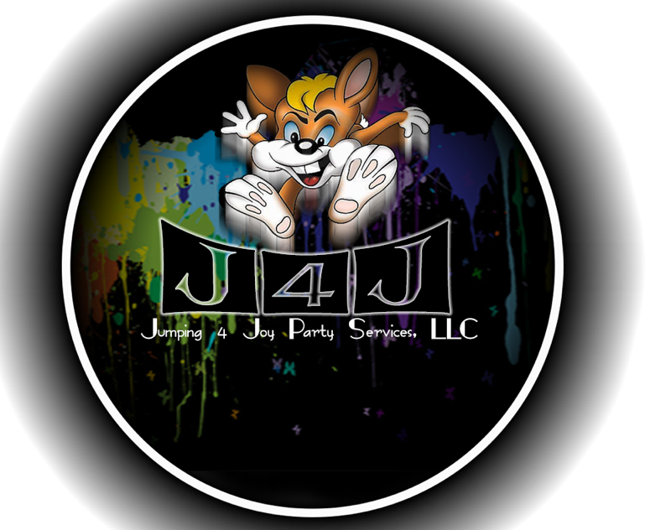

**Jumping 4 Joy Party Services, LLC**

**safety rules**

The safety of the children (and adults) using J4J’s inflatables and other equipment is our number one priority. Safety truly depends on the presence of adult supervision AT ALL TIMES!!! Please review the safety rules and operator safety agreement prior to using the inflatable(s) and machinery.

* I understand that I am responsible for the inflatable(s) and/or other equipment until Jumping 4 Joy Party Services, LLC’s staff returns to pick up the equipment.
* I understand that I should never leave the inflatable(s) or machine(s) unattended.
* I understand that while children are in the inflatable a responsible adult must be supervising.
* I acknowledge the recommendation for the maximum number of occupants in or on the inflatable at one time, and I agree not to exceed this number/weight capacity. I understand that occupants should be sorted by size to prevent injuries. Only children of approximately the same age/size should be in the inflatable at the same time.
  + Maximum of 8 children between the ages of 2 to 8 years
  + Maximum of 5 children between the ages of 8 to 12 years
  + Maximum of 3 teens and/or adults at any given time
  + Maximum of 2 children in the pool area of the combination inflatable
  + Maximum of 1 person on the slide at any given time
    - No sliding down when there is someone in the sliding path.
  + Keeping the ages and size of groups well-managed will help to minimize the chances of someone getting injured.
* I understand that occupants shall not attempt to pull or climb on the mesh (window) nets, as doing so may cause the inflatable to collapse.
* Safety and evacuation procedures in case of unit deflation have been reviewed with me.
* I will not allow anyone who is intoxicated or under the influence of drugs to utilize the inflatable or other machinery, as serious injury may occur.
* I will ensure that all occupants remove their shoes and any sharp objects before entering the inflatable. Sharp objects include eyeglasses, toys, jewelry, and any item that could scratch the unit or another occupant.
* I understand that food and drinks are not allowed inside the inflatable, including gum.
* I understand that there is no smoking allowed in or around the inflatable unit. Hot embers will burn a hole and/or create damage to the unit. If this occurs, I understand that I am liable.
* Unless the inflatable is specifically designed to hold water, the unit should not get wet.
* I will not allow occupants to do flips, climb the netting or roof areas, horseplay or rough-house in the inflatable. I will remove occupants who do not follow directions to ensure the safety of all other occupants.
* I will not allow anyone to sit or play on the safety step. The step is not a bouncing platform.
* I understand that occupants should be sorted by size to prevent injuries. Only children of approximately the same age/size should be in the inflatable at the same time.
* I am aware of how weather can affect the inflatable and/or machinery, and I have reviewed the procedures and understand what to do in the event of bad weather (rain or wind).
* I understand that exposed appendages may rub against the side of the slide, so in order for occupants to avoid friction burns, they must slide in a seated position: feet first, ankles crossed, and arms crossed. Jumping and flipping from the top of the slide (if available) is not permitted and can cause injuries.

_____________________________ __________ _____________________________

Signature of the Lessee Date Signed Jumping 4 Joy Party Services, LLC